What Is Web Scraping?

**Web scraping** is the process of gathering information from the Internet. Even copy-pasting the lyrics of your favorite song is a form of web scraping! However, the words “web scraping” usually refer to a process that involves automation. Some websites don’t like it when automatic scrapers gather their data, while others don’t mind.

If you’re scraping a page respectfully for educational purposes, then you’re unlikely to have any problems. Still, it’s a good idea to do some research on your own and make sure that you’re not [violating](https://benbernardblog.com/web-scraping-and-crawling-are-perfectly-legal-right/) any Terms of Service before you start a large-scale project. To learn more about the legal aspects of web scraping, check out [Legal Perspectives on Scraping Data From The Modern Web](https://www.lawinsociety.org/legal-perspectives-on-scraping-data-from-the-modern-web).

**Why Scrape the Web?**

Say you’re a surfer (both online and in real life) and you’re looking for employment. However, you’re not looking for just any job. With a surfer’s mindset, you’re waiting for the perfect opportunity to roll your way!

There’s a job site that you like that offers exactly the kinds of jobs you’re looking for. Unfortunately, a new position only pops up once in a blue moon. You think about checking up on it every day, but that doesn’t sound like the most fun and productive way to spend your time.

Thankfully, the world offers other ways to apply that surfer’s mindset! Instead of looking at the job site every day, you can use Python to help automate the repetitive parts of your job search. **Automated web scraping** can be a solution to speed up the data collection process. You write your code once and it will get the information you want many times and from many pages.

In contrast, when you try to get the information you want manually, you might spend a lot of time clicking, scrolling, and searching. This is especially true if you need large amounts of data from websites that are regularly updated with new content. Manual web scraping can take a lot of time and repetition.

There’s so much information on the Web, and new information is constantly added. Something among all that data is likely of interest to you, and much of it is just out there for the taking. Whether you’re actually on the job hunt, gathering data to support your grassroots organization, or are finally looking to get all the lyrics from your favorite artist downloaded to your computer, automated web scraping can help you accomplish your goals.

**Challenges of Web Scraping**

The Web has grown organically out of many sources. It combines a ton of different technologies, styles, and personalities, and it continues to grow to this day. In other words, the Web is kind of a hot mess! This can lead to a few challenges you’ll see when you try web scraping.One challenge is **variety**. Every website is different. While you’ll encounter general structures that tend to repeat themselves, each website is unique and will need its own personal treatment if you want to extract the information that’s relevant to you. Another challenge is **durability**. Websites constantly change. Say you’ve built a shiny new web scraper that automatically cherry-picks precisely what you want from your resource of interest. The first time you run your script, it works flawlessly. But when you run the same script only a short while later, you run into a discouraging and lengthy stack of [tracebacks](https://realpython.com/python-traceback/)!This is a realistic scenario, as many websites are in active development. Once the site’s structure has changed, your scraper might not be able to navigate the sitemap correctly or find the relevant information. The good news is that many changes to websites are small and incremental, so you’ll likely be able to update your scraper with only minimal adjustments.However, keep in mind that because the internet is dynamic, the scrapers you’ll build will probably require constant maintenance. You can set up [continuous integration](https://realpython.com/python-continuous-integration/) to run scraping tests periodically to ensure that your main script doesn’t break without your knowledge.

**APIs: An Alternative to Web Scraping**

Some website providers offer **Application Programming Interfaces (APIs)** that allow you to access their data in a predefined manner. With APIs, you can avoid parsing HTML and instead access the data directly using formats like [JSON](https://realpython.com/courses/working-json-data-python/) and XML. HTML is primarily a way to visually present content to users.When you use an [API](https://realpython.com/python-api/), the process is generally more stable than gathering the data through web scraping. That’s because APIs are made to be consumed by programs, rather than by human eyes. If the design of a website changes, then it doesn’t mean that the structure of the API has changed.to APIs just as they do to websites. Additionally, it’s much harder to inspect the structure of an API by yourself if the provided documentation is lacking in quality.The approach and tools you need to gather information using APIs are outside the scope of this tutorial. To learn more about it, check out [API Integration in Python](https://realpython.com/api-integration-in-python/).

**Requests - Overview**

Requests is a HTTP library that provides easy functionality to deal with http request/response in your web application. The library is developed in python.

***Features of Requests***

**Request:** The python requests library has easy to use methods available to handle Http request. Passing of parameters and handling the request type like GET, POST, PUT, DELETE, etc. is very easy.

**Response:** You can get the response in the format you need and the supported ones are text format, binary response, json response, and raw response.

**Headers:** The library allows you to read, update or send new headers as per your requirements.

**Timeouts:** Timeouts can be easily added to the URL you are requesting using python requests library. It so happens that you are using a third-party URL and waiting for a response.It is always a good practice to give a timeout on the URL as we might want the URL to respond within that timeout with a response or an error that is coming because of timeout. Not doing so can cause either to wait on that request indefinitely.

**Error handling:** The requests module gives support for error handling and some of which are Connection Error, Timeout errors, TooManyRedirects, Response.raise_for_status errors, etc.

**Cookies:** The library allows you to read, write and update for the requested URL.

**Sessions:** To maintain the data, you require between requests you need sessions. So, if the same host is called again and again you can re-use the TCP connection which in turn will improve the performance.

**SSL certificates:** SSL certificate is a security feature that comes with secure urls. When you use Requests, it also verifies SSL certificates for the https URL given. SSL Verification is enabled by default in the requests library and will throw an error if the certificate is not present.

**Authentication:** HTTP authentication is on the server-side asking for some authentication information like username, password when the client requests a URL. This is an additional security for the request and the response being exchanged between the client and the server.

***Advantages of using Python Requests Library***

Following are the advantages of using Python Requests Library −

* Easy to use and fetch the data from the URL given.
* Requests library can be used to scrape the data from the website.
* Using requests, you can get, post, delete, update the data for the URL given.
* The handling of cookies and session is very easy.
* The security is also taken care of the help of authentication module support.

***Requests - Environment Setup***

we will work on the installation of Requests. To start working with the Requests module, we need to install Python first.

* Install Python
* Install Requests

***Installing Python***

Go to the Python official site: <https://www.python.org/downloads/> as shown below and click on the latest version available for Windows, Linux/Unix, and Mac OS. Download Python as per your 64 or 32 bit OS available with you. Once you have downloaded, click on the .exe file and follow the steps to install python on your system.

The python package manager, i.e., pip will also get installed by default with the above installation. To make it work globally on your system, directly add the location of python to the PATH variable. The same is shown at the start of the installation to remember to check the checkbox which says ADD to PATH. In case you forget to check it, please follow the below-given steps to add to PATH.

To add to PATH follow the steps−Right-click on your Computer icon and click on properties > Advanced System Settings.

* Click on Environment Variables as shown above. It will display the screen as shown below
* Select Path and click on Edit button, add the location path of your python at the end. Now, let us check the python version.

***Checking the python version***

E:\prequests>python --version

Python 3.7.3

***Requests - How Http Requests Work?***

Python’s Requests is a HTTP library that will help us exchange data between the client and the server. Consider you have a UI with a form, wherein you need to enter the user details, so once you enter it, you have to submit the data which is nothing but a Http POST or PUT request from the client to server to save the data.

When you want the data, you need to fetch it from the server, which is again a Http GET request. The exchange of data between the client when it requests the data and the server responding with the required data, this relationship between the client and the server is very important.

The request is made to the URL given and it could be a secure or non-secure URL.

The request to the URL can be done using GET, POST, PUT, DELETE. The most commonly used is the GET method, mainly used when you want to fetch data from the server.

Using the request library, the URL is called as follows using a string dictionary.

Wherein the data to the URL is sent as a dictionary of strings. If you want to pass id=9 and username=Delphine, you can do as follows−

payload = {'id': '9', 'username': 'Delphine'}

The requests library is called as follows−

res = requests.get('[https://www.noon.com/egypt-en/'](https://jsonplaceholder.typicode.com/users), params=payload')

*Using POST*

res = requests.post(‘https://www.jumia.com.eg/', data = {'id':'9', 'username':'Delphine'})

*Using PUT*

res = requests.put(‘https://egypt.souq.com/eg-ar/’, data = {'id':'9', 'username':'Delphine'})

The response from the Http request can be in text encoded form, binary encoded, json format or raw response. The details of the request and response are explained in detail in the next chapters.

***Requests - Working with Requests***

* Making HTTP Requests.
* Passing Parameters to HTTP Requests.

***Making HTTP Requests***

To make a Http request, we need to first import the request module as shown below−

import requests

Let us now see, how to make a call to URL using the requests module.

Example

url = "https://www.noon.com/_svc/catalog/api/search"

response = requests.request("POST", url, headers=headers, json=payload).json()

w=response.get('hits')

print(response.status_code)

The url− https://www.noon.com/_svc/catalog/api/search is called using requests.get() method. The response object of the URL is stored in the(w) variable. When we print the variable, it gives the 200 response code, which means that we have got the response successfully.

*Output*

E:\prequests>python makeRequest.py

<Response [200]>

Handling Response for HTTP Requests

In this part, we will get into more details of the response received from the requests module. We will discuss the following details−

* Getting Response
* JSON Response
* RAW Response
* Binary Response

Getting Response

We will make a request to the URL using request.get() method.

  payload={"brand":[],"category":l,"filterKey":[],"f":{},"sort":{"by":"popularity","dir":"desc"},"limit":50,"page":page_number}

  response = requests.request("POST", url, headers=headers, json=payload)

  if(response.status_code==429):

    print('error 429')

    time.sleep(5)

    w=Datapayload()

  else:

    response=response.json()

    w=response.get('hits')

JSON Response

You can also get the response for the Http request in json format by using response.json()

import requests

import time

import psycopg2

def des(sku,offer_code):

    url1 = f"https://www.noon.com/_svc/catalog/api/u/{sku}/p?o={offer_code}"

    response1 = requests.request("GET", url1, headers=headers1, data=payload1)

    if(response1.status_code==429):

      print('error 429')

      time.sleep(20)

      a=des(sku,offer_code)

    else:

      response1=response1.json()

      a=response1['product']['feature_bullets']

    return(a)

Requests - HTTP Requests Headers

**Custom Headers**

You can also send headers to the URL being called as shown below.

**Example**

import requests

import time

import psycopg2

payload1={}

headers1 = {

  'authority': 'www.noon.com',

  'pragma': 'no-cache',

  'cache-control': 'no-cache, max-age=0, must-revalidate, no-store',

  'x-locale': 'en-eg',

  'x-content': 'mobile',

  'x-mp': 'noon',

  'user-agent': 'Mozilla/5.0 (iPhone; CPU iPhone OS 13_2_3 like Mac OS X) AppleWebKit/605.1.15 (KHTML, like Gecko) Version/13.0.3 Mobile/15E148 Safari/604.1',

  'x-cms': 'v2',

  'accept': 'application/json, text/plain, */*',

  'x-platform': 'web',

  'sec-fetch-site': 'same-origin',

  'sec-fetch-mode': 'cors',

  'sec-fetch-dest': 'empty',

  'referer': 'https://www.noon.com/egypt-en/iphone-12-pro-max-with-facetime-256gb-graphite-5g-middle-east-version/N41044056A/p?o=e0211e466e4a3c6a',

  'accept-language': 'en-US,en;q=0.9',

}

def des(sku,offer_code):

    url1 = f"https://www.noon.com/_svc/catalog/api/u/{sku}/p?o={offer_code}"

    response1 = requests.request("GET", url1, headers=headers1, data=payload1)

    if(response1.status_code==429):

      print('error 429')

      time.sleep(20)

      a=des(sku,offer_code)

    else:

      response1=response1.json()

      a=response1['product']['feature_bullets']

    return(a)

The headers passed has to be string, bytestring, or Unicode format. The behavior of the request will not change as per the custom headers passed.

Response Headers

The response headers look like below when you check the URL in the browser developer tool, network tab−To get the details of the headers from the requests module use.

*Example*

lists=[['electronics-and-mobiles/mobiles-and-accessories'],['electronics-and-mobiles/computers-and-accessories'],['electronics-and-mobiles/video-games-10181'],['electronics-and-mobiles/television-and-video'],['electronics-and-mobiles/camera-and-photo-16165'],['electronics-and-mobiles/portable-audio-and-video'],['electronics-and-mobiles/wearable-technology'],['electronics-and-mobiles/home-audio'],['electronics-and-mobiles/accessories-and-supplies']]

for l in lists:

  l=l

  page_number=1

  a=True

  while a :

    url = "https://www.noon.com/_svc/catalog/api/search"

    payload="{\"brand\":[\"apple\"],\"category\":[\"electronics-and-mobiles/mobiles-and-accessories/mobiles-20905\"],\"filterKey\":[],\"f\":{},\"sort\":{\"by\":\"popularity\",\"dir\":\"desc\"},\"limit\":50,\"page\":2}"

    headers = {

    'authority': 'www.noon.com',

    'pragma': 'no-cache',

    'cache-control': 'no-cache, max-age=0, must-revalidate, no-store',

    'x-locale': 'en-eg',

    'x-content': 'mobile',

    'x-mp': 'noon',

    'x-platform': 'web',

    'x-cms': 'v2',

    'content-type': 'application/json',

    'accept': 'application/json, text/plain, */*',

    'user-agent': 'Mozilla/5.0 (iPhone; CPU iPhone OS 13_2_3 like Mac OS X) AppleWebKit/605.1.15 (KHTML, like Gecko) Version/13.0.3 Mobile/15E148 Safari/604.1',

    'origin': 'https://www.noon.com',

    'sec-fetch-site': 'same-origin',

    'sec-fetch-mode': 'cors',

    'sec-fetch-dest': 'empty',

    'referer': 'https://www.noon.com/egypt-en/electronics-and-mobiles/mobiles-and-accessories/mobiles-20905/apple',

    'accept-language': 'en-US,en;q=0.9,ar;q=0.8'}

    Datapayload()

    print(page_number)

    page_number+=1

Requests - Handling GET Requests

This chapter will concentrate more on the GET requests, which is the most common and used very often. The working of GET in the requests module is very easy. Here is a simple example about working with the URL using the GET method.

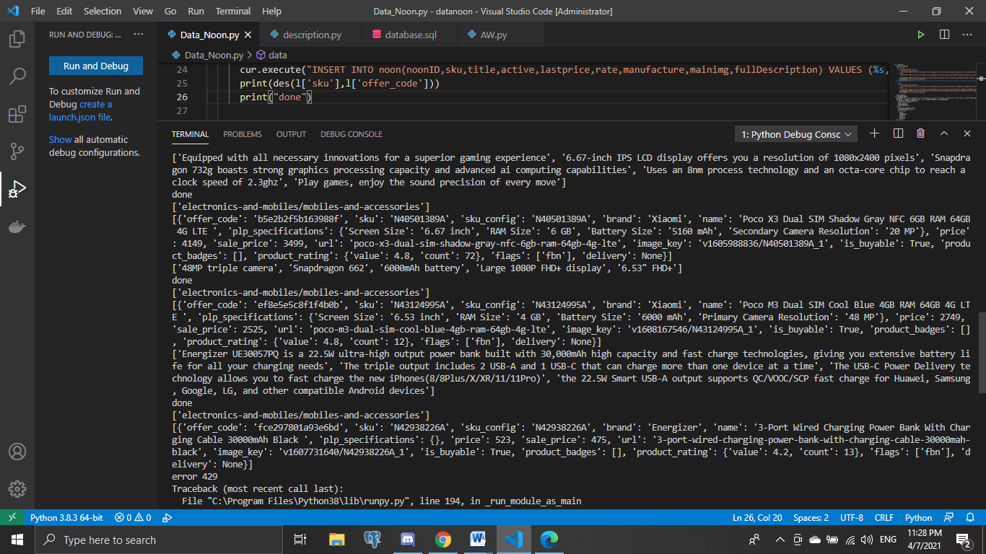

Oop

Introduction to Object-oriented programming

In order to begin understanding the intuition behind this programming technique, let’s take a look at an initial example. Imagine that you have to describe a car to someone who’s never seen one before, how would you do it?

You might want to start saying that it’s a wheeled motor vehicle used for transportation. Also, you might say that there are several brands of car-maker companies, which make different types of cars that fulfill various needs. In an even more basic level you might say that it has four tires, that they carry up to five people in most cases and that they are mainly used to transport people, not goods.

When explaining to a computer what kind of object this is, it’s a good idea to approach it in a similar way. Computers have no innate idea of what a car is, why were they created or who uses them. And if you want your computer to correctly understand the object, a car in this case, you have to clearly explain which are its attributes.

To make it easier for computers to understand these new concepts, Python uses a programming pattern called **object-oriented programming**, which models concepts using classes and objects. This is a flexible, powerful paradigm where classes represent and define concepts, while **objects are instances of** **classes**. In the car example, we can create a class called car that defines its characteristics to the computer. We would be able to create thousands of instances of that class car, which are the individual objects of that class.

The idea of object-oriented programming might sound abstract and complex, but if you’ve programmed any software you might have already used objects without even realizing it. **Almost everything in Python is an object**, all of the numbers, strings, lists, and dictionaries are included in this type of element. The core concept of object-oriented programming comes down to **attributes**and **methods**associated with a type:

* **Attributes**are the characteristics associated to a type.
* **Methods**are the functions associated to a type.

In the car example, color and brand are two attributes associated with every instance, or car, created with the program. On the other hand, methods would be actions performed with or by the car, such as driving. A more computer-oriented example would be a file in a directory, as every file has a name, a size and a date of when it was created.

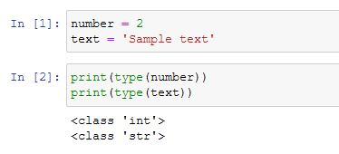

As you can see in the image above, when we use the **type**function as we just did here, Python tells us which class the value or variable belongs to. And since **integers**and **strings**are classes, they have a bunch of attributes and methods associated with them. You can access attributes and methods of a class with the **dir** function in Python, as shown below:

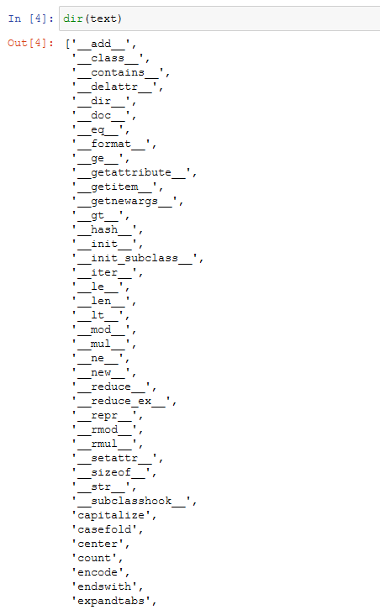

different **instance**of the string class. This means that they all have the same methods, although the content in the string is different.

## Why are there a bunch of methods that begin and end with double underscores?

These are called **special methods**and theyaren’t usually called by those weird names. Instead, they’re called by some of the internal Python functions. for example, the **__len__** method is called by the **len**function.

If you want to know what a specific method does, you should use the **help** function:

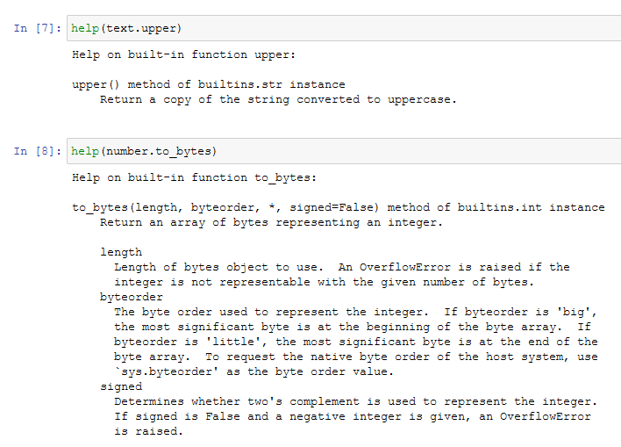

When we use the **help**function on any variable or value, we’re accessing all the documentation for the corresponding class. In this case, we’re looking at the documentation for the **str**and the **int** class.

Although Python comes with a lot of predefined classes for us, the power of **object-oriented programming**comes when we define our own classes with their own attributes and methods.

Defining a New Class

As mentioned earlier, the point of object oriented programming is to help define a real-world concept in a way that the computer understands. Let’s get hands on to build a new class with the car example:

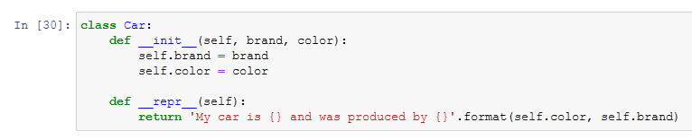

Let’s clarify specific elements of the code:

* In Python, we use the **class**reserved keyword to tell the computer that we’re starting a new class. We follow this with the name of the class and a colon. Python style guidelines recommend that class names should start with a **capital letter**. In my case, the class is called Car.
* After the line with the class definition comes the body of the class, which is indented to the right, following the pattern of [loops or functions](https://towardsdatascience.com/understand-loops-in-python-with-one-article-bace2ddba789?source=your_stories_page-------------------------------------).
* We’ll get to the special methods **init**and **repr** in the fourth section of this article.

**How might we expand our definition of the Car class?**It would probably have the same attributes that represent the information we want to associate with a car like brand and color.

Now, let’s proceed with the creation of an instance of the class Car, and assign it to a variable called “my_car”. To create a new instance of any class, we call the name of the class as if it were a function:



As you can see, I’m passing as an argument the brand and the color as I’ve configured my class to require both items in the creation of a new object of the class. As a result, we can call the attributes of the created instance and receive the value previously assigned:

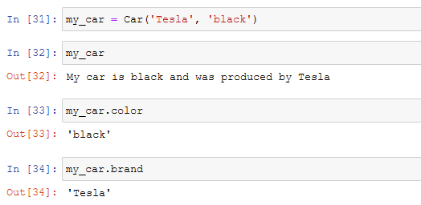

The syntax used to access the attributes is called **dot notation**because of the dot used in the expression. Dot notation lets you access any of the abilities that the object might have, such as brand or color.

The attributes and methods of some objects can be other objects and can have attributes and methods of their own. For example, we could use the upper or the capitalize methods to modify both string attributes of my instance:

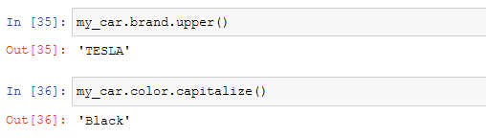

So far we’ve created one instance of the Car class and set its attributes. Now, we could create a new instance of the the class with different attributes:

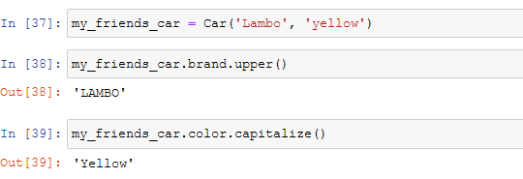

Instance Methods

Methods are essentially called to make objects do stuff. For example, **upper** and **capitalize**for strings. The key to learn the intuition of methods in O.O.P. is to understand that **methods are functions that operate on the attributes of a specific instance of a class**. When we call the **lower**method on the string, we’re making the contents of that specific string lowercase.

Let’s take a closer look by creating a new class called **Dog**and defining our own methods. First, we need to define the class and create an instance of it like we’ve done before with the Car class. While my dog might be great, it can’t perform any actions as long as I don’t define methods for them. Take a look at the example:

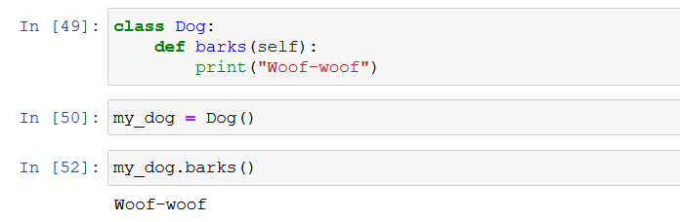

As shown in the image, we must start defining a method with the **def**keyword just like we would for a function, and indent to the right the body of the method, also as we would for a function.

The function is receiving a parameter called “self”. This parameter represents the instance that the method is being executed on.

Even though my dog barks, it will always do it in the same way. We can change how it will bark with a simple modification in the code, in order to gain flexibility in the attributes and methods that we configure to our classes:

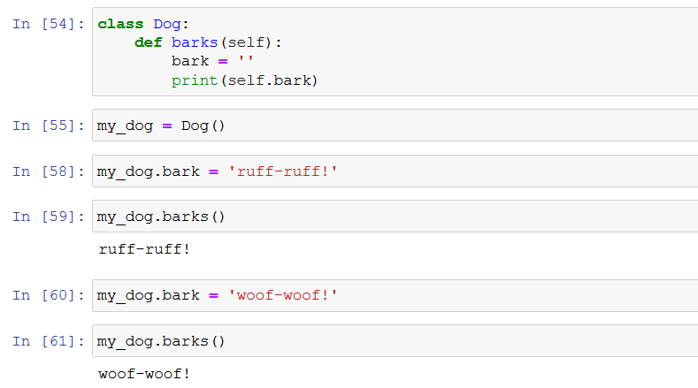

Defining Constructors and Other Special Methods

Both classes created up to this paragraph contain default values as attributes and methods. This is not an ideal scenario as it creates redundant code for each attribute, and more importantly, **as it makes it really easy to forget to set an important value**.

So, when writing code it's a good idea to set attributes and methods that will vary with instances upon creating the class, in order to make sure that each instance contains the same important attributes. To do this, **we need to use a special method called Constructor**.

*The constructor of the class is the method that's called when you call the name of the class. It's always named****init****.*

It contains the keyword self, which refers to the instance being created, and the arguments that will be passed as attributes by the programmer once the instance is created, like we do in the example below:

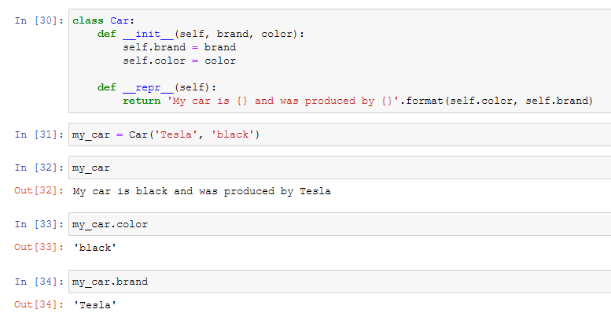

The second method of the class is the **repr**method, which tells Python to print a predetermined statement every time an instance of the class is called, as in the image above.

**Want to know which is a specific method’s function?** Refer to the **help** function introduced previously. As built-in classes include a guide to help users understand the intuition behind each method or attribute, we could also do this on our own classes, methods, and functions. We can do that by adding a **Docstring**.

*A Docstring is a brief text that explains what something does.*

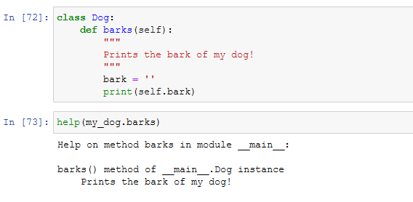

Once you include documentation to your classes and objects, you’ll get much more information about the methods created that will facilitate re-usability of the code and help other users to understand it. Remember that the docstring always has to be indented at the same level of the block it’s documenting.

Code Reuse

Another important aspect of object-oriented programming is **Inheritance**. Just like people have parents, grandparents, and so on, objects have an ancestry. The principle of inheritance lets a programmer build relationships between concepts and group them together. In particular, this allows us to reduce code duplication by generalizing our code.

For example, how can we define a representation of “**other means of transport”** apart from the car that we already created, or other pets apart from my dog. This grouping characteristic allows us to create other classes that share some of the attributes of the existing classes, but not all of them, in order to add other similar instances without rewriting existing code. 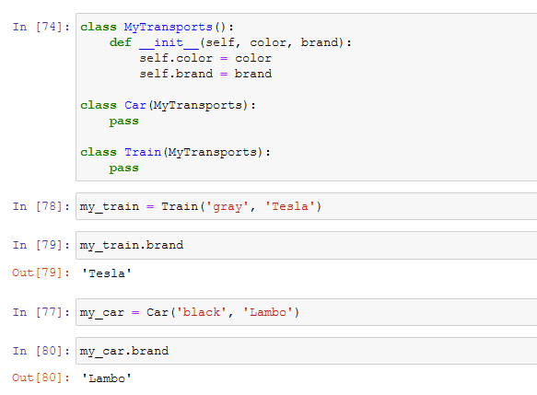

In Python, we use parentheses in the class declaration to show an inheritance relationship. In the transportation example above, I’ve used Python’s syntax to tell the computer that both the car and the train inherit from the MyTransports class. Because of this, they automatically have the same constructor, which sets the color and brand attributes.

With the inheritance technique, we can use the transportation class to store information that applies to all kinds of transports available, and keep car or train specific attributes in their own classes. You can think of the MyTransports class as the parent class, and the Car and Train classes as siblings.

An example that is closer to the tasks you would perform in an IT department would be a system that handles the employees at your company. You may have a class called employee, which could have the attributes for things like full name of the person, the username used in company systems, the groups the employee belongs to, and so on. The system could also have a manager class which also is an employee, but additional information associated with it, like the employees that report to a specific manager.